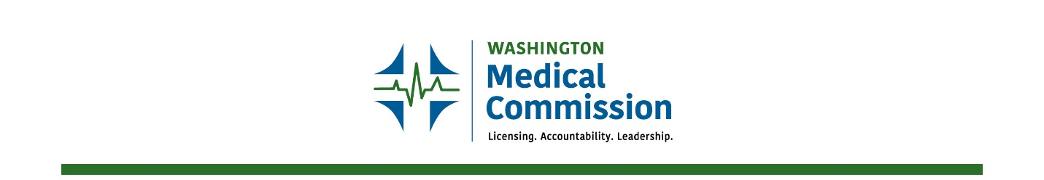
360-236-2750 | PO Box 47866 | Olympia, Washington 98504-7866 | Medical.Commission@WMC.wa.gov

2021 IMG Workgroup Norms

Every successful group/organization has an agreed upon set of norms and expectations by which they operate. Those adopted by the IMG Implementation Workgroup are as follows:
Norms
- We assume positive intent from all members and staff.
- We recognize that we are all here to successfully address the charge put to us in the legislation.
- We respect the qualifications, background, and journey of all those participating.
- We commit to fully participating in the Workgroup and its functions.
- We agree to the consensus model of decision-making whenever possible.
- We agree to openly discuss concepts with the group at meetings and not in the chat feature.
Expectations
- Be timely and attend meetings whether remotely or in-person.
- Accept that votes can and will be taken at each meeting, regardless of the absence of a specific member.
- Provide information supported by facts and evidence.
- Respond to communications within two business days.
- Receive agendas the week prior to a meeting.
- Focus on the topics and decisions the legislature has laid out for us.

